[2012]
[Team Assignment 01] | Team 02 – The HIT

Class K15T2 | SOFTWARE PROJECT MANAGEMENT PLAN

Revision History
Date | Version | Description | Author
6/3/2011 | 1.0 | Consume Team member’s tasks | Thanh Giang

- INTRODUCTION

  - Purpose of this document
This section of the Software Project Management Plan (SPMP) gives an overview of the business context and the architectural drivers with their impact on the project. It also contains the project deliverables, the summary of the schedule the SPMP. We also show the development strategy that we choose to show how this may affect the design of a system.

  - Project Summary
Company A, a retail chain, has decided to develop a sales system (hereinafter, the system) in conjunction with its launch of a point service.
The system consists of a head office server, located at the head office, and the POS terminals placed at store cashiers. The head office server and the POS terminals are connected to each other via a network. Products sold at stores have bar codes attached which indicate the product codes. These bar codes can be read with bar code readers of POS terminals.
Customer who have become point service members are issued point cards, which bear bar codes indicating their member numbers, and when they purchase products with cash, they are awarded points based on the amount of their purchase. The point award rate is fixed, and stored in the system as constant.
Point are recorded in the system, and not on the point card. The awarded points become valid for use the following day, and can be used by the member who accrued the points in place of cash when making a purchase. Points can be used in all stores.
For each product, its standard price, common to all stores, is set as a part of the product data. Each store, however, can set and use its own actual retail price instead of the standard price during the limited period specified be each store. The actual retail price must be set in advance, and it cannot be charged in the middle of the specified period.
Products are classified into product types such as food, general merchandise, etc. Not all stores carry every product type, and the range of product types carried is designated for each store.
Moreover, in addition to the sales operation, the system is also capable of performing the statistical analysis on the sales records of all stores in near real-time manner.
Both the head office server and the POS terminals are equipped with a Database, and both the head office server Database and the POS terminal Database can be accessed during the sales operation.
The statistical analysis of the sales records is performed using the sales data stored at the head office server.

  - Document's intended audience
Intended Audience | Reading Suggestions
Project Manager | Section 2 – The architectural Drivers: List functions showed by use-case diagrams and constrains to make the Project Manager has an overview. So he can have the estimates for the project.  Section 3 – The development Strategy
Software Architecture and Designer | Section 2 – The architectural Drivers: This section describes Use-case diagram and Use-case descriptions. It makes easily to design and develop the proposed system.
Tester | The Overview section and Use-case: they will help to make the test plan and write the acceptance test

- The architectural drivers

  - High-level Functional Requirements
Use Case ID | Use Case Name | Important Level | Difficulty Level

System Management
UC_SM01 | Add New User | High | Medium
UC_SM02 | Search/ View User List | Medium | Low
UC_SM03 | View User Log | Low | High
UC_SM04 | View User Detail Information | Normal | Low
UC_SM05 | Assign Authorize | High | High
UC_SM06 | Update User Information | Normal | Medium
UC_SM07 | Sync Information | High | High

Product Management
UC_PM01 | Add New Product | High | Medium
UC_PM02 | Search/ View Product List | Medium | Low
UC_PM03 | View Product Detail Information | Medium | Low
UC_PM04 | Choose Category | Medium | Low
UC_PM05 | Update Product Information | Medium | Medium

Record Management
UC_RM01 | Add New Record | High | High
UC_RM02 | Search/ View Record List | Medium | Low
UC_RM03 | View Record Detail Information | Medium | Low
UC_RM04 | Print Record | Medium | Medium

Retail Stores Management
UC_RSM01 | Add New Store | High | Medium
UC_RSM02 | Search/ View Store List | Medium | Low
UC_RSM03 | View Store Detail Information | Medium | Low
UC_RSM04 | Update Store Information | Medium | Medium

Category Management
UC_CM01 | Add New Category | High | Medium
UC_CM02 | Search/ View Category List | Medium | Low
UC_CM03 | View Category Detail Information | Medium | Low
UC_CM04 | Update Category Information | Medium | Medium

Customer Management
UC_C01 | Add New Customer | High | Medium
UC_C02 | Search/ View Customer List | Medium | Low
UC_C03 | View Customer Detail Information | Medium | Low
UC_C04 | Update Customer Information | Medium | Medium
UC_C05 | View Customer Point Log | High | Medium
UC_S01 | Statistic Information | Low | High

    - Use-case Diagrams and Use-case Descriptions

Note Table:
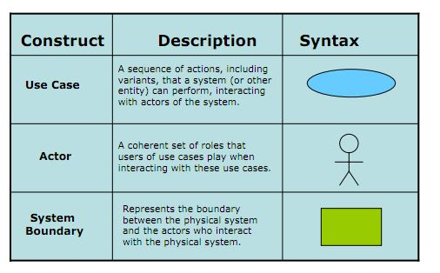
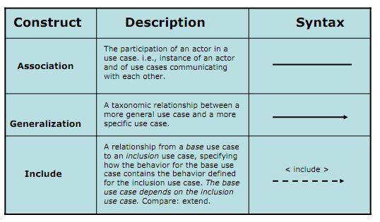

Level 1 – Retail Sales System

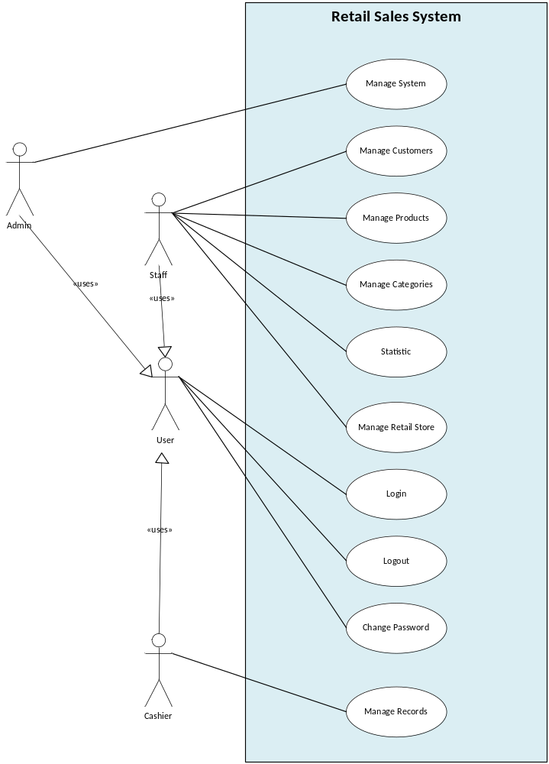

Level 2 - System Management

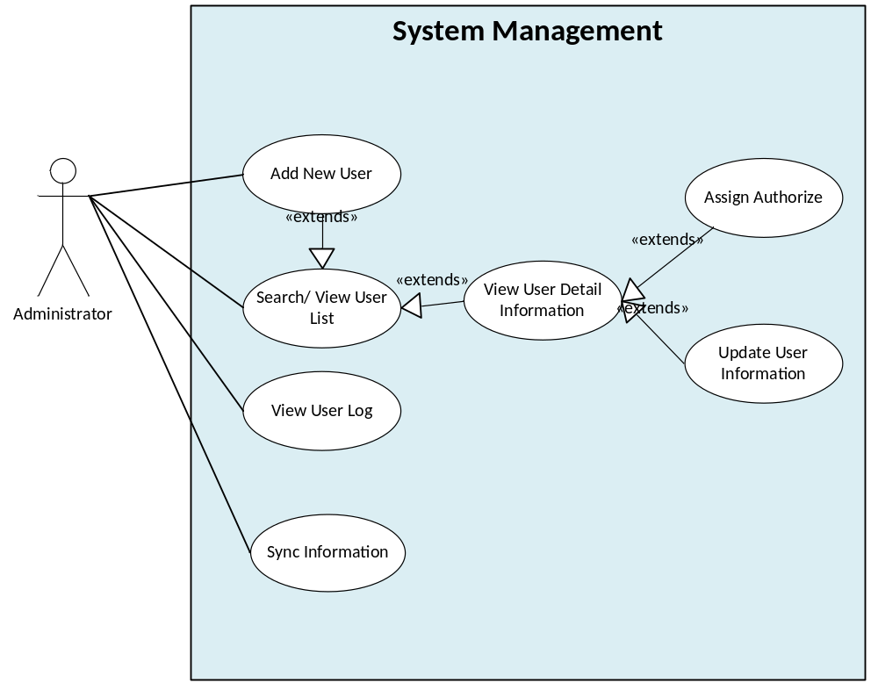

Level 2 - Customer Management

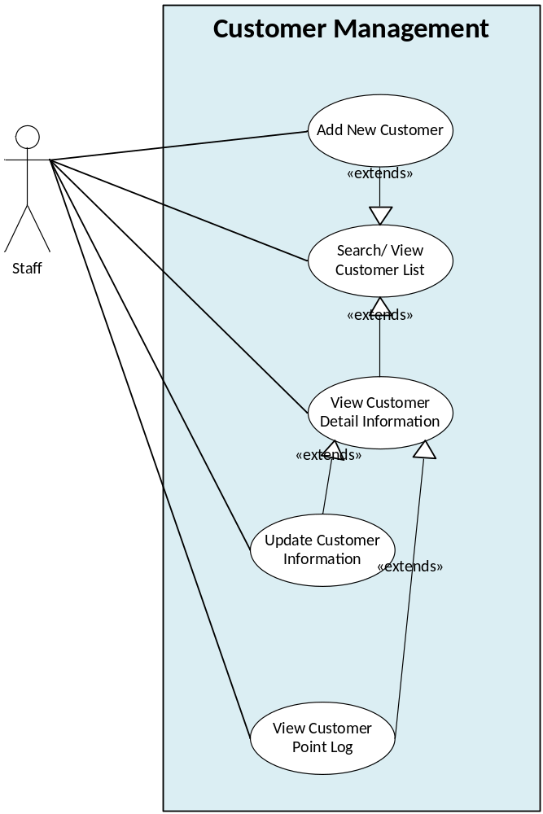

Level 2 - Product Management

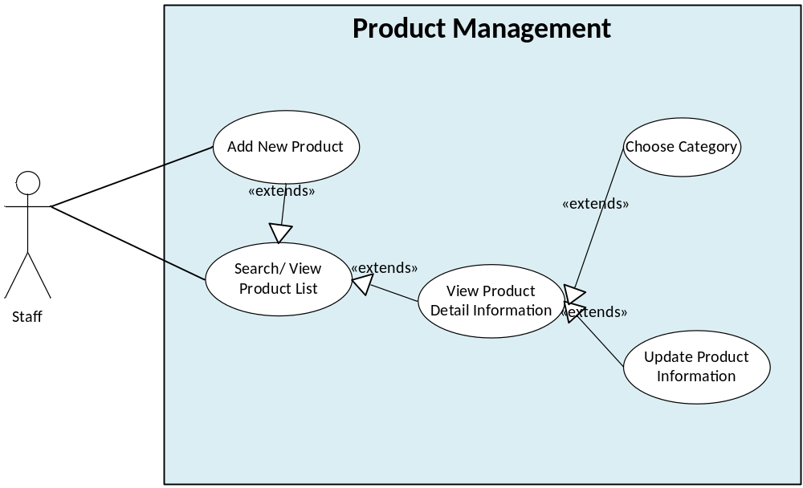

Level 2 - Category Management

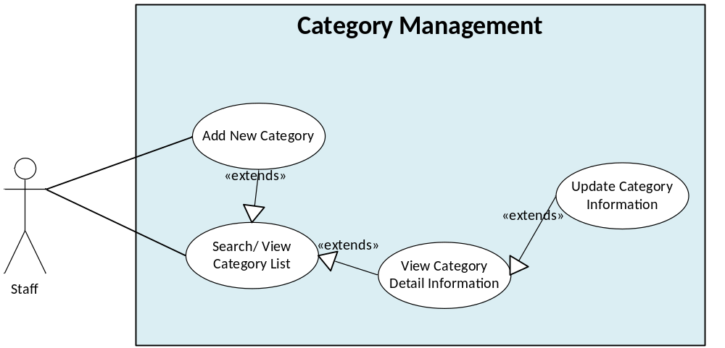

Level 2 - Record Management

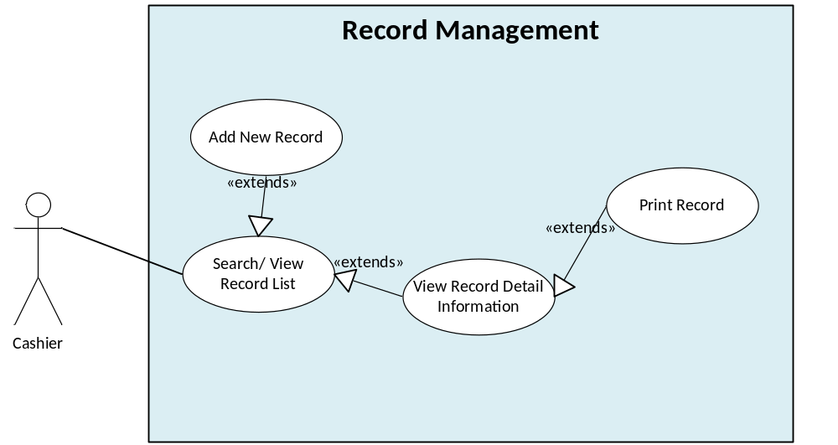

Level 2 - Retail Stores Management

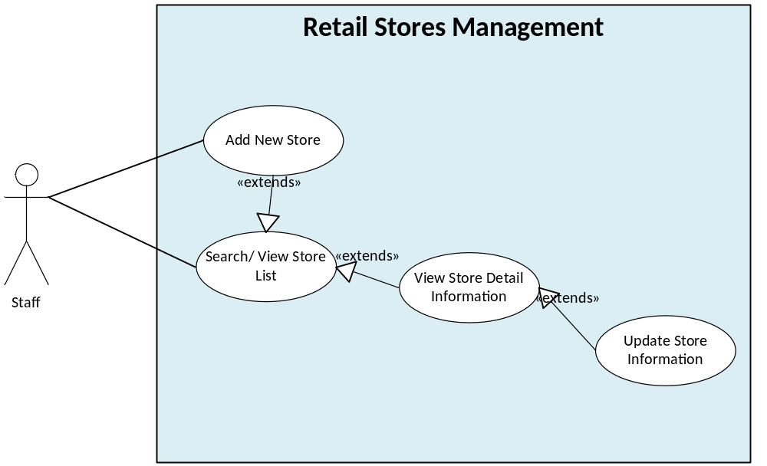

    - Use-case Descriptions
Use Case Title: Add New Store | Use Case ID: UC_RSM01

General Use Case Description: This use case help the manager add new sale store. This function can also split products of retail stores that are consumed, as well as regulate the product price.

Entities Involved: Staff, Retail Store

Preconditions:
- User is assigned authorized to use this function
- User has chosen Retail Stores Management function
- The system is available

Primary Use Case Flow of Events:
- User choose “Add new store” button
- Program displays Add new store interface
- User fills in Store name text field
- User fills in Address text field
- User chooses a Category
- Program displays Products which has in that Category
- User chooses a Product
- Program add the product which user just has chosen to the Product List with the standard Price
- User can edit the Price base on how much the store want to sell that product.
- User clicks "OK".
- Program shows message "Are you sure you want to create new retail store’s information as above?"
- User clicks "OK" to confirm
- The system stores the retail store’s information that has just been created and returned to retail store management interface
- End Use-case

Primary Use Case Post Conditions:
Successful: Create new successful. The system stores the retail store’s information that has just been created and returned to retail store management interface

Fail: Failed to create new

Alternate Use Case #1 Flow of Events:
There is a store with already name (starting from step 11 of the main flow)

- Program shows message "Are you sure you want to create new retail store’s information as above?"
- User clicks "OK" to confirm
- Program check in database and found that it has a store with already name
- Program display warning dialog “There is a store with already name. Please fill in again”
- End Use-case

Alternate Use Case #1 Post Events:

Use Case Title: Sync Information | Use Case ID: UC_SM01

General Use Case Description: This use case help the administrator synchronize information between retail stores and head office: mostly customer’s points needs to be updated to be able to use immediately the next day

Entities Involved: Administrator

Preconditions:
- User use this function at the end of the day when all sessions are finished
- The system is available

Primary Use Case Flow of Events:
- User choose “Sync Information” button
- Program displays Sync Information interface
- User choose the retail store want to sync with the head office
- User choose type what to sync: all or just customer point
- User choose “Sync” button
- Program syncs information between the head office with those retail stores
- Program shows message “Sync Information Successful”
- End Use-case

Primary Use Case Post Conditions:
Successful: Sync Successful

Fail: Failed to sync OK

Alternate Use Case #1 Flow of Events:
Can’t access the retail store’s database (starting from step 6 of the main flow)

- Program syncs information between the head office with those retail stores
- Program shows message “Sync Information Successful”
- End Use-case

Alternate Use Case #1 Post Events:

Use Case Title: Add New Record | Use Case ID: UC_RM01

General Use Case Description: This use case helps cashiers who work at retail stores make bill-paying for customers. Cashier can use barcode reader or directly enter the product code and product number by keyboard, then use the payment function to save to database and printed out bills for customers.

Entities Involved: Cashier, Retail Store

Preconditions:
- User is assigned authorized to use this function
- User has chosen Record Management function
- The system is available.

Primary Use Case Flow of Events:
- User choose “Add new record” button
- Program displays Add new store interface
- User fills in Bar Code text field
- User choose “Add” button
- The system load information from database to the “Product List” table on the interface.
- User fills in Quantity text field
- User scan or fill in customer Loyalty card ID
- The system load information from database and show customer name with their point on the interface
- If customer want to use their point to pay bill, User choose “Type to pay bill”
- There are three ways to pay bill:
  - Pay by cash: User does not fill in “Point” text field. The system auto shows all the money customer has to pay in “Cash” text field.
  - Pay by point: User fills in “Point” text field if user has enough point to pay that bill, the system auto shows “0 VND” in “Cash” text field.
  - Pay by point and cash: User fills in “Point” text field, the system shows money that customer still has to pay with that bill in “Cash” text field.
- User choose “Pay by Cash”
- User choose Pay bill button
- The system stores the record’s information that has just been created and prints the bill. Then the program returns to record management interface
- End Use-case

Primary Use Case Post Conditions:
Successful: Create new successful. The system stores the record’s information that has just been created and prints the bill. Then the program returns to record management interface

Fail: Can’t print the bill

Alternate Use Case #1 Flow of Events:
The bar code is invalid (starting from step 5 of the main flow)

- Program loads information from database and shows message “The bar code is invalid”
- User clicks "OK" to confirm
- Program allows user to retype the bar code
- End Use-case

Alternate Use Case #1 Post Events:

  - Constrains:

    - Business Constrains:
Consideration | ID | Business Constraints.
Cost limitations. | BC01 | None
Schedule limitations. | BC02 | 6 weeks
Mandatory regulatory restrictions and demands. | BC02 | Customers who have become point service members are issued point cards. Points can be used in all stores.  The member the either pays with cash, points, or a combination of the two
Legal restrictions and demands. | BC03 | None
Market restrictions and demands. | BC04 | The actual retail price must be set in advance.
Organizational restrictions and demands. | BC05 | One team with 6 members
Logistical issues. | BC06 | None

    - Technical Constrains:
Consideration. | ID | Technical Constraints
Computer operating system(s). | TC01 | None
Computer platform(s). | TC02 | None
Computer languages(s). | TC03 | None
Peripheral or network hardware. | TC04 | Database server
Commercial hardware or software products. | TC05 | Bar code readers  Keyboard
Tools and methods. | TC06 | SQL Database Server
Protocols, interfaces, standards. | TC07 | TCP/IP protocol
Legacy hardware and software. | TC08 | None

  - Quality Attributes

Quality Attribute Ranking Table
Quality Attribute | Important (base on customer) | Difficult level (to implement) | Priority
Performance | High | High | High
Availability | High | High | High
Usability | Medium | Low | Low
Security | Medium | Medium | Medium

    - Performance:

This is sales system; we must always ensure that customer service was not delayed. Intervals such as scan the point card, bar code scanning, displaying results... will be done in the shortest time possible to avoid the dissatisfy customer. Things that need attention are: increased client response time, reduced throughput, and server resource over utilization. Ensure that you structure the application in an appropriate way and deploy it onto a system or systems that provide sufficient resources.
Example of Performance Attribute: Users initiate 100 transactions per minute at 100 POS terminal under overload operations, and these transactions are processed with an average latency of two seconds.
Portion of scenario | Possible values
Source | User
Stimulus | 100 transactions per minute at 100 POS terminal
Artifact | System
Environment | Overload operation
Response | These transactions are processed
Response Measure | 2 seconds

    - Availability:
This system has two servers located at the head office server and POS terminal, if the failure occurs at head office server or the network; we need the system still available and working normal at the POS terminal.
Example of Availability Attribute: The temporary failure of the head office server, the POS terminal will be still working securely. The POST terminals can carry out the sales operation efficiently using locally stored data as much as possible.

Portion of scenario | Possible values
Source | Head office database
Stimulus | Temporary failure of the head office server
Artifact | System
Environment | Normal operation
Response | To be still working securely and carry out the sales operation efficiently using locally stored data.
Response Measure | No down time

    - Usability:

The application interfaces must be designed with the user and consumer in mind so that they are intuitive to use, provide a good overall user experience. This quality attribute help the user (cashier) easier to manipulate functions to help the sale progress better.

    - Security:

We must consider to the capability of a system to reduce the chance of malicious or accidental actions outside of the designed usage affecting the system, and prevent disclosure or loss of information. Improving security can also increase the reliability of the system by reducing the chances of an attack succeeding and impairing system operation. Securing a system should protect assets and prevent unauthorized access to or modification of information.
- The factors affecting system security are confidentiality, integrity, performance and availability. So when we apply the performance and availability attribute to this system, we should make attention to balance or tradeoff between them.
- The features used to secure systems are authentication, encryption, auditing, and logging
Apply waterfall model to this project, we estimate schedule for 6 week follow:

- Project Scope

  - Project strategy
Within 6 week, Team decided:
- Choose basic function to deliver to customer:
  - Manage system
  - Manage Customer
  - Manage Product
  - Manage Categories
  - Manage Retail Store
  - Manage Record
  - Log in
  - Log out
  - Change password
Because this function is important function, easy to development and must have to operation Sales System of a retail chain using a loyalty card point system
- Defer statistic function because this function do not so important, requirement about this function still not clear and hard to development

  - Team working Flow
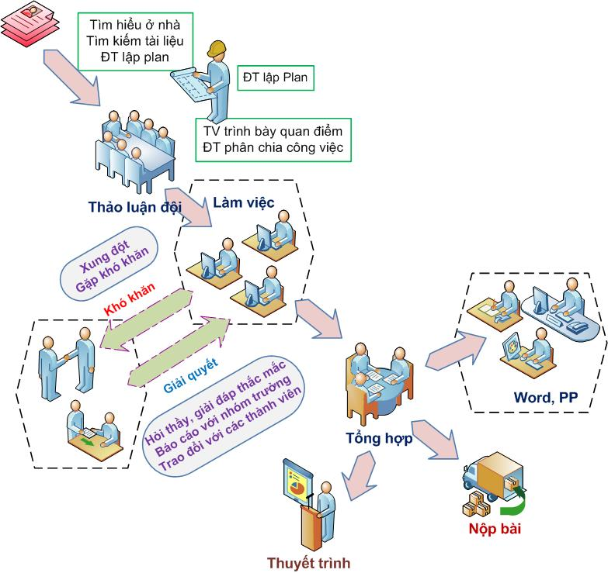

  - Mile-stone:
ID |  | Task | Mile-stone
1 | RE | Propose | 10-3-2012
1 | RE | Concept Of Operation | 13-3-2012
1 | RE | SRS, Test plan | 17-3-2012
2 | Design | Architect Design | 24-3-2012
2 | Design | Detail Design | 28-3-2012
3 | Implement | Manage System | 29-3-2012
3 | Implement | Manage Customers | 30-3-2012
3 | Implement | Manage Products | 1-4-2012
3 | Implement | Manage Categories | 2-4-2012
3 | Implement | Manage Retail Store | 3-4-2012
3 | Implement | Manage Records | 4-4-2012
3 | Implement | Product - Version 1 | 5-4-2012
4 | Test | System test | 12-4-2012
4 | Test | Unit test | 16-4-2012
5 | Delivery | Final project | 20-4-2012

  - Roles and Responsibilities:
Name | Roles
Giang Thị Hà Thanh | Project Manager
Nguyễn Vũ Trọng Giang | Tester
Nguyễn Trần Hồng Phúc | Requirement Engineering
Trần Dũng đạt | Developer
Tạ Quang Hiệp | Designer
Huỳnh Chấn Huy | architecture

  - Risk:

Risk | Priority | Mitigation
Estimate the time is too far from real | High
Lack of time on Class | High
Customer change requirements or addition requirement | Medium
Not fully reviewed documents | Medium
Unskillful members-programming skill | Medium
Developing the wrong user interface | Low
Absent the team meetings | Low

Team decided to use Waterfall model to develop Sales System of a retail chain using a loyalty card point system, because:
- It’s easy to apply, to understand and manage
- Suitable for this projects (small projects and requirements have not changed much)
- Output document of each stage are being built and more fully.

